Project Design Phase-II

Data Flow diagrams and User stories

|  |  |
| --- | --- |
| Date | 12 October 2022 |
| Team ID | PNT2022TMID51589 |
| Project Name | Predicting the Energy Output of Wind  Turbine Based on Weather Condition |
| Maximum Marks | 4 Marks |

**Data Flow Diagrams:**

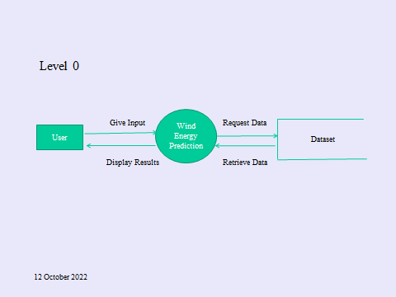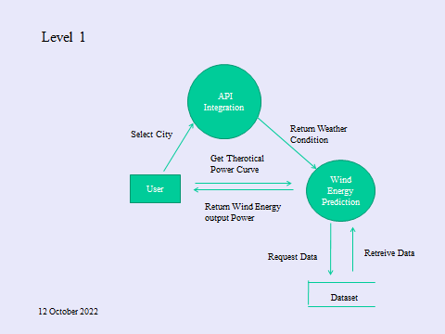

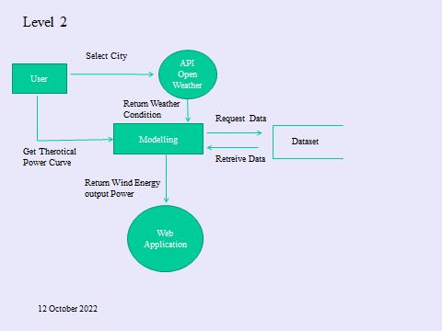

**User Stories:**

|  |  |  |  |  |  |  |
| --- | --- | --- | --- | --- | --- | --- |
| User Type | Functional Requirements | User Number Story | User Story/User Task | Acceptance Criteria | Priority | Release |
| Customer | Home(Application) | USN-1 | As a user, I can view the guideline as well as the detailed information about the  application | I can gain knowledge by practical method to use this application . | Low | Sprint-1 |
|  |  | USN-2 | As a User, I can use this application by  reading the instructions | I can use this in user friendly method by  reading the instruction. | Low | Sprint-1 |
|  |  | USN-3 | As a User, I can login and by entering the correct  username and password | If login is correctly entered ,I can navigate to the next page. | Low | Sprint-2 |
|  |  | USN-4 | As a user ,I am allowed to select the city and can get the weather of the  city. | I can select the city ,If the city is correct I can further enter the details. | Medium | Sprint-3 |

|  |  |  |  |  |  |  |
| --- | --- | --- | --- | --- | --- | --- |
|  |  | USN-5 | As a user I am allowed to view the weather of the selected city. | If correct city is selected  ,then the weather of the particular city  will be displayed. | Medium | Sprint-4 |
|  |  | USN-6 | As a User ,I can view the Power generated by the wind | If all values are entered correctly I can view the power  generated by the | High | Sprint-5 |
|  |  | USN-7 | As a User, I can use the web application virtually anywhere | I can use the application portably | High | Sprint-2 |
|  |  | USN-8 | As it is open source ,I can use it cost freely. | I can use it without any  payment to access | Medium | Sprint-2 |